Amy Inoa, Jelissa Reyes, Rahfat Chowdhury

Professor Gil Eckert

CS 104

**Sprint 3 - Agility Design Document**

**December 01, 2021**

**Table of Contents**

1. **Executive Summary**

1.1 Project Overview

1.2 Purpose and Scope of this Specification

1. **Product/Service Description**

2.1 Product Context

2.2 User Characteristics

2.3 Assumptions

2.4 Constraints

2.5 Dependencies

1. **Requirements**

3.1 Functional Requirements

3.2 Security

*3.2.1 Protection*

*3.2.2 Authorization and Authentication*

*3.3* Portability

1. **Requirements Confirmation/Stakeholder sign-off**
2. **System Design**

5.1 Algorithm

5.2 System Flow

5.3 Software

5.4 Hardware

5.5 Test Plan

5.6 Task List/Gantt Chart

5.7 Staffing Plan

1. Executive Summary

***1.1 Project Overview***

Your robot will run the obstacle course. The course will start in a square. Then the

robot will encounter 3 objects which it must avoid.. Next, the robot will go over the ramp.Finally, the robot will knock over as many pins as possible. Points added for each obstacle the robot completes, for each obstacle avoided and, for each pin the robot topples.

***1.2 Purpose and Scope of this Specification***

**In scope**

Testing for the Agility course

**Out of Scope**

Testing for the Endurance course

Testing of Accuracy course

1. Product/Service Description

*2.1* ***Product Context***

This is the Agility sprint which is the third leg of 3 total sprints including an endurance sprint prior and an accuracy prior.

*2.2* ***User Characteristics***

Create general customer profiles for each type of user who will be using the product. Profiles should include:

* Students will use this product to fulfil course needs.
* The professor will use the product to check functionality.
* This product can be used for mapping out a perimeter of an obstacle course.

*2.3* ***Assumptions***

* Robot Srk+ should be fully charged and available for testing.
* Room HH208 should be open and available for testing.
* Group members should be available and ready for testing.
* Course should be placed intact.

*2.4* ***Constraints***

Describe any items that will constrain the design options, including

* Robot cannot go off course
* Room HH208 not being open at certain times
* Robot died mid course
* Meeting with groups was difficult at times due to different schedules

*2.5* ***Dependencies***

List dependencies that affect the requirements.

* Depending on the availability of the room, testing of the course may not be possible
* Other groups may limit the amount of time we have for testing
* Furniture may obstruct the course
* The floor tape may disrupt how the robot runs the course

3. Requirements

3.1 ***Functional Requirements***

| **Req#** | **Requirement** | **Comments** | **Priority** | **Date**  **Rvwd** | ***SME***  ***Reviewed/***  ***Approved*** |  |
| --- | --- | --- | --- | --- | --- | --- |
| AGIL_01 | Robot must start on the allotted X |  | 1 | 12/1/21 | Approved - Amy,Rahfat, Jelissa |  |
| AGIL_02 | Robot must roll in a forward direction at 0 degrees. | Code didn't need readjusting if aim was correct | 1 | 12/1/21 | Approved - Amy,Rahfat, Jeliss |  |
| AGIL_03 | Robot must stop and then turn at a 93 degree angle and then stop and then repeat AGIL_02 |  | 1 | 12/1/21 | Approved - Amy,Rahfat, Jeliss |  |
| AGIL_04 | Robot must stop and turn to go in a fast motion to make it over the binder |  | 1 | 12/1/21 | Approved - Amy,Rahfat, Jeliss |  |
| AGIL_05 | Robot must be able to jump the corner and make a complete stop and then turn at a 225 angle towards the markers. |  | 2 | 12/1/21 | Approved - Amy,Rahfat, Jeliss |  |
| AGIL_06 | Robot must pick up enough speed to knock down the markers |  | 2 | 12/1/21 | Approved - Amy,Rahfat, Jeliss |  |
| AGIL_07 | Robot must successfully knock over markers |  | 2 | 12/1/21 | Approved - Amy,Rahfat, Jeliss |  |
|  |  |  |  |  |  |  |

*3.2*  ***Security***

*3.2.1* ***Protection***

*Specify the factors that will protect the system from malicious or accidental access, modification, disclosure, destruction, or misuse. For example:*

* Block code is protected by Sphero Edu User and password log in
* App is protected by personnel login information

*3.2.2* ***Authorization and Authentication***

* Only personnel working on the Agility course have access to the code.
* Program could only run if logged into a personal device and Sphero edu app.

*3.3* ***Portability***

*If portability is a requirement, specify attributes of the system that relate to the ease of porting the system to other host machines and/or operating systems. For example,*

* Robot can only run on course in room HH208
* Robot cannot function if not connected to a nearby device

4. Requirements Confirmation/Stakeholder sign-off

| Meeting Date | Attendees (name and role) | Comments |
| --- | --- | --- |
| 12/01/2021 | Jelissa (organizer), Amy (organizer), Rahfat (organizer) | Setup SDD, gantt chart, requirements table, algorithm, coding(video, code, and running the robot) and staffing plan |
| 12/02/2021 | Jelissa (organizer), Amy (organizer), Rahfat (organizer) | Worked on SDD, gantt chart, flow chart, and upload everything onto github |

5. System Design

*5.1* ***Algorithm***

***First, the robot will start at 0 degrees at 60 speed for 1.7 seconds.***

***The robot will delay for 1 second.***

***Then the robot will roll at 93 degrees at 60 speed for 1.8 seconds.***

***The robot will delay 1 second.***

***Then the robot will roll at 0 degrees again at 60 speed for 2.16 seconds.***

***The robot will delay 1 second.***

***Then the robot will roll at 93 degrees again at 150 speed for 1.98 seconds.***

***The robot will delay 1 second.***

***Finally, the robot will roll at 225 degrees at 150 speed for 3 seconds.***

*5.2* ***System Flow***

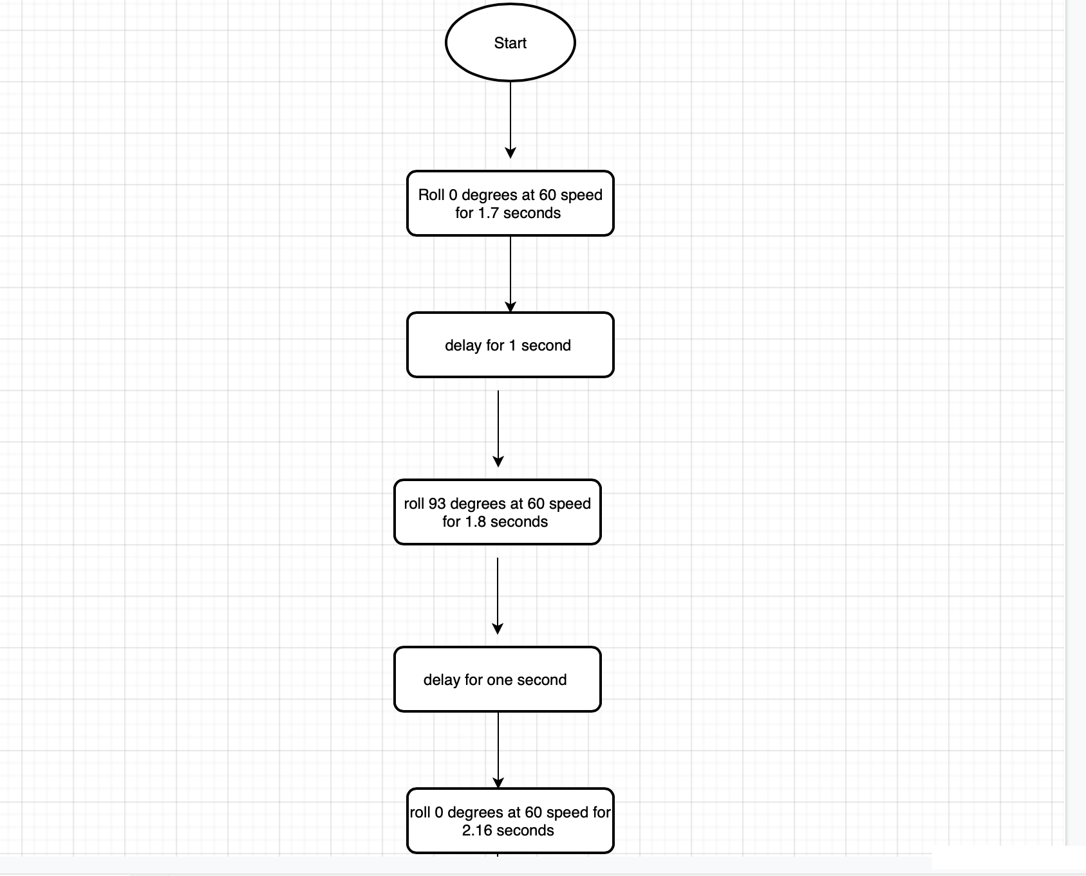

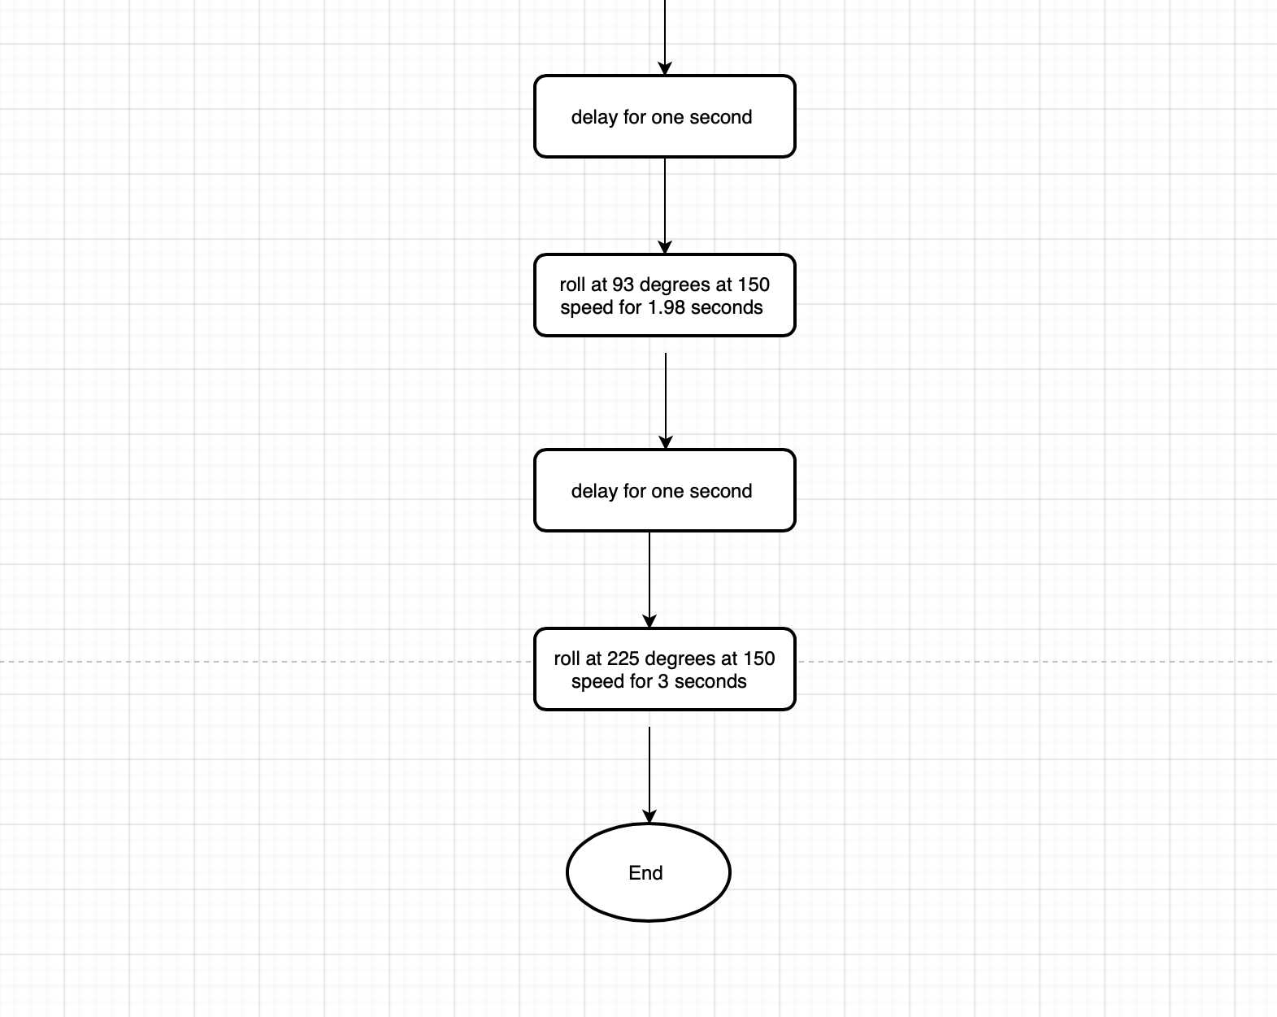

*5.3* ***Software***

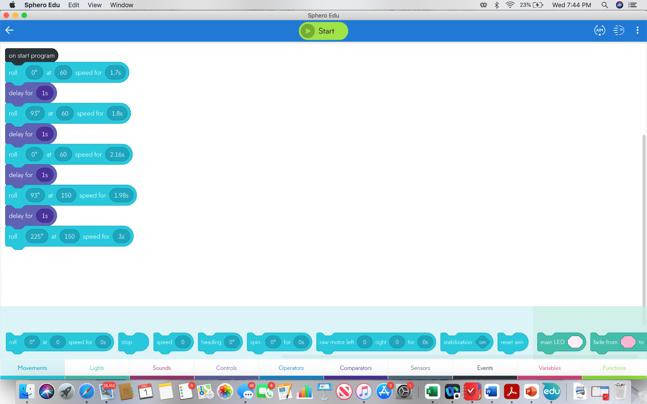

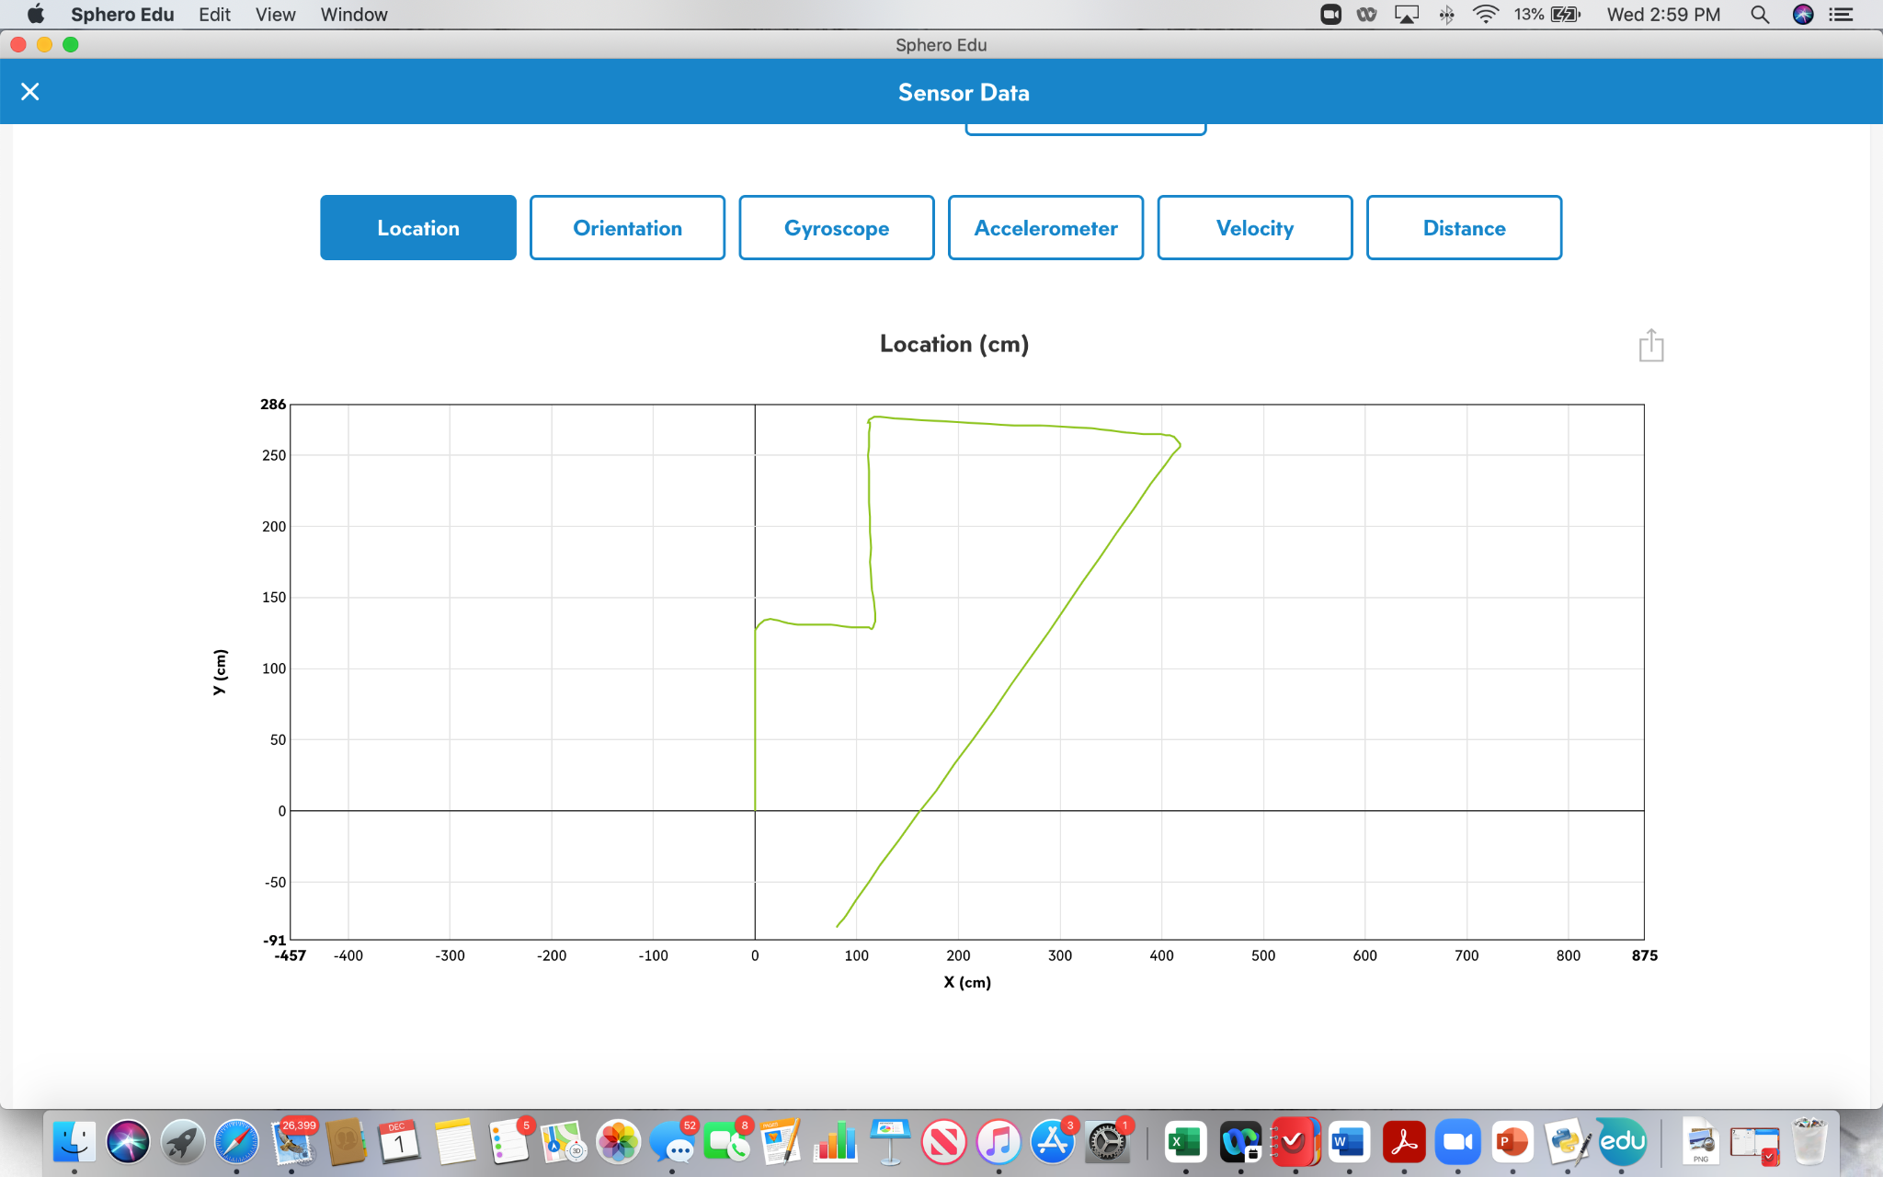

*5.4* ***Hardware***

*Sphero Sprk+ Robot*

*Laptop*

*5.5* ***Test Plan***

| **Reason for Test Case** | ***Test Date*** | ***Expected out come*** | ***Observed***  ***Output*** | ***Staff Nam*** | ***Pass/Fail*** |
| --- | --- | --- | --- | --- | --- |
| Testing for speed and timing for the first leg of the zig zag | 12/1 | Robot went in a straight line and did not collide with the glass bottle | Robot went straight and did not hit the glass bottle | jelissa | pass |
| Testing the speed and seconds for the first into second leg of the zig zag | 12/1 | Robot should go in a straight line and then turn the corner avoiding the glass bottle | Robot completed the first leg, but collided with the second glass bottle | jelissa | Fail |
| Testing first and second leg with more accuracy on aim | 12/1 | Robot should go in a straight line then turn the corner avoiding glass bottle | Robot went in a straight line then turned the corner with no collision | Amy | pass |
| Testing if robot completes zig zag portion of course | 12/1 | Robot should go in a straight line then turn the first corner avoiding the glass bottle, and then turn the second corner without collision | Robot collided with the second bottle and stopped | rahfat | Fail |
| Testing increasing the second for the 2nd and 3rd leg of the zig zag, and as well as angle change of the first corner | 12/1 | Robot should go in a straight line then turn the first corner avoiding glass bottle, and then turn the second corner without collison | Robot turned the first and second corner without collision with a change of angle on the first corner to 93 degrees | Amy | pass |
| Testing the speed of which the robot had to get to go over the binder | 12/1 | Robot should complete zig zag and then roll over binder | Robot completed a zig zag and rolled over the binder successfully | jelissa | pass |
| Testing seconds and angle of which the robot had to continue to move after landing off the binder | 12/1 | Robot should land off the binder and roll to the corner, and turn and roll straight knocking over the pins | Robot landed off the binder and rolled to the corner where it turned at a correct angle and went straight knocking over some of the “pins”. | rahfat | pass |
| Testing full course to see if it will complete course successfully | 12/1 | Robot should complete full course successfully | Robot completed full course successfully, knocking over all pins except for 1. | Jelissa | pass |
|  |  |  |  |  |  |

*5.6* ***Task List/Gantt Chart***

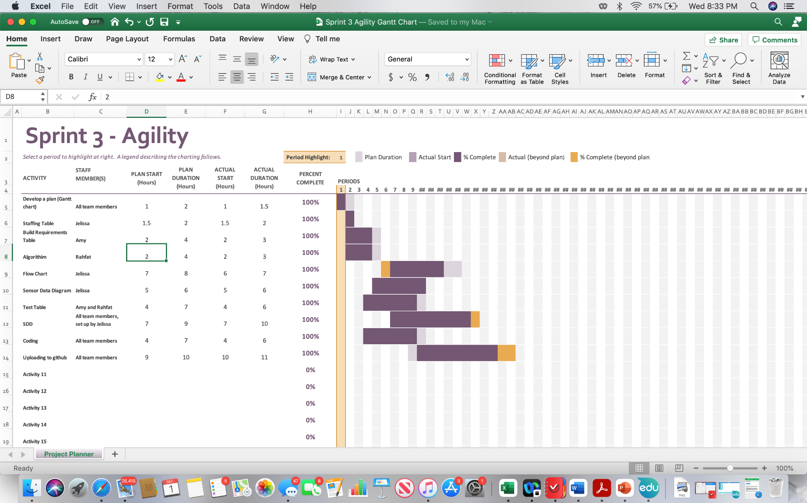

5.7 ***Staffing Plan***

| Name | Role | Responsibility | Reports to |
| --- | --- | --- | --- |
| Jelissa | Organizer | -Setup SDD, gantt chart and staffing plan  -Flowchart  -Coding (running robot and setting up block code)  -Sensor Data Diagram | Amy and Rahfat who are helping with coding and doing their documents they were assigned. Rahfat is taking the video. |
| Amy | Organizer | -Help with SDD  -Coding (running robot and setting up block code)  -requirements table  -Test Table | Jelissa and Rahfat who will be helping with coding which allows the test table to be done and helping with the SDD |
| Rahfat | Organizer | -help with SDD  -coding (running and setting up block code)  -take video  -algorithm  -help with test table | Jelissa and Amy who will be helping with coding which allows the test table to be done and taking video of the robot. Algorithm from requirements table. |